**INTRODUCTION**

The **Offline Examination Portal** includes login page of students, registration of students, getting student’s feedback of the subjects etc., and storing their details into the system. This software has the facility to give a unique id for every student and stores the details of every student automatically.

In this project students and teachers can login by entering using their username and password. All the data in the database is accessible by an administrator they could add, update or remove any student details and also add the questions and answers required for the offline examination. Teacher can enter student details or update their details and can change their password and each teacher can add questions according to the subject they teach and conduct an offline examination for the students. Student could give the feedback about exam which is visible for both teachers and the admin. The interface is very user-friendly. The data are well protected for personal use and makes the data processing very fast.

**PROJECT ANALYSIS**

**2.1 GOALS OF PROPOSED SYSTEM**

1. **Planned approach towards working:** The working in the organization willbe well planned and organized. The data will be stored properly in data stores, which will help in retrieval of information as well as its storage.
2. **Accuracy:** The level of accuracy in the proposed system will be higher. Alloperation is done correctly and it ensures that whatever information is coming from the center is accurate.
3. **Reliability:** The reliability of the proposed system will be high due to theabove stated reasons. The reason for the increased reliability of the system is that now there would be proper storage of information.
4. **No Redundancy:** In the proposed system utmost care would be that noinformation is repeated anywhere, in storage or otherwise. This would assure economic use of storage space and consistency in the data stored.
5. **Immediate retrieval of information:** The main objective of proposedsystem is to provide for a quick and efficient retrieval of information. Any type of information would be available whenever the user requires.
6. **Immediate storage of information:** In manual system there are manyproblems to store the largest amount of information.
7. **Easy to Operate:** The system is easy to operate and is developed within a short period of time.

**2.2 EXISTING SYSTEM**

The existing system was not so consistent because of maximum manual work. All the work that is done until now is done by human intervention. As all the work is done manually, there were maximum chances of errors. The interface of student, teacher and administrator is maximum. Due to the above problems every procedure becomes time consuming. Updating was very difficult and ambiguous. The duplication of records was usual hence data redundancy. Also, main disadvantage is it’s time consuming.

**2.3 LIMITATIONS OF EXISTING SYSTEM**

* Lack of security of data.
* Time consuming.
* Consumes large volume of paper work.
* Manual work
* No direct role for the higher officials.

To avoid all these limitations and make the system working more accurately it needs to be computerized.

**2.4 OBJECTIVES OF PROPOSED SYSTEM**

The ‘Offline Examination Portal’ software is user-friendly software. The main objective of the system is to conduct tests for students eventually improving their skills. Also this software eliminates the burden of registering new students and teachers manually. The system is very simple in design and to implement. The system requires very low system resources and the system will work in almost all configurations.

**SYSTEM SPECIFICATIONS**

**3.1 HARDWARE REQUIREMENTS**

|  |  |  |
| --- | --- | --- |
| CPU | - | Pentium core i3 / i5 / i7 |
| RAM | - | 512 MB |
| HDD | - | 40 GB |

**3.2 SOFTWARE REQUIREMENTS**

|  |  |  |
| --- | --- | --- |
| OPERATING SYSTEM | - | Windows 10 / 8 / 7 / Xp |
| USER-INTERFACE | - | Java Swing |
| APPLICATION | - | NetBeans IDE 8.0.2 |
| STORING DATABASE | - | MySQL |

**SYSTEM DESIGN**

**4.1 INTRODUCTION**

Design is the place where quality is fostered in development. Software design is a process through which requirements are translated into a representation of software. Design is the first step in the development phase for any techniques and principles for the purpose of defining a device, a process or system in sufficient detail to permit its physical realization.

Design activities are of main importance in this phase, because in this activity, decisions ultimately affecting the success of the software implementation and the ease of maintenance are made. These decisions have the final bearing upon reliability and maintainability of the system. Design is the only way to accurately translate the customer’s requirements into finished software or a system.

Software design is conducted in two steps. Preliminary design is concerned with the transformation of requirements into data. Next is implementation process where the software requirements are analyzed. After the software requirements have been analyzed and specified the software design involves three technical activities –design, coding, implementation and testing that are required to build and verify the software.

**4.2 BLOCK DIAGRAM**

Admin Login Page

Student/Teacher Login Page

Home page

Profile

Profile

New Student /Teacher Registration

Feedback form

Change Password

Change Password

Update Student

Attend test (Student)/

Add Questions (Teacher)

Test Modifications

Student/Teacher Login Page

Admin Login Page

**4.3 UNIFIED MODELING LANGUAGE DIAGRAMS**

Unified Modeling Language (UML) is a graphical Language for modeling software systems. UML is a set of diagrams that can be used to specify, construct, visualize, and document explain their software designs. UML has diagrams to assist in every part of the application development process from requirements gathering through design, and into coding, testing and deployment.

We use UML for developing ant product after analysis. The goal from this is to produce a model of entities involved in the project which is later need to be built. The representations of the entities that are to be used in the product being developed are needed to be designed.

*History of UML Language:*

UML was originally motivated by the desire to standardize the disparate notational systems and approaches to software design developed by Grady Booch, Ivar Jacobson and James Rumbabugh at Rational Software in1994-1995, with further development led by them through 1996. In 2005 UML was officially publicized by the International Organization for Standardization.

Symbols used in UML Diagrams:

* Use case
* Actor
* Association
* Include Relationships

*Use case:*

Use case diagrams specify the events of a system and are used to gather the requirements of a system including internal and external influences. It shows the interaction among the requirements is actors.

*Actor:*

An actor specifies a role played by a user or any system that interacts with the subject.

Actor

*Association:*

An association is a connection between an actor and use case. An association indicates that an actor can carry out a use case.

Association

*Include Relationship:*

An include relationship is a relationship between two use-cases. It indicates that the use case to which the arrow points is included in the use case on the other side of the arrow. This makes it possible to reuse a use case in another use case.

Include Relationship

Diagrams used in UML:

* Use-case Diagram
* Sequence Diagram
* Collaboration Diagram
* Activity Diagram
* State chat Diagram

*Use Case Diagrams*

A use case diagram is a simple diagram that shows who is using a system and what process will be performed in that system. It is mainly used to document the requirements , gathering and analysis workflows. Throughout the entire development, all work should be traceable back to the use case diagram.

Use case diagrams model behavior within a system and helps the developers understand of what the user require. This can be useful for getting an overall view of the system and clarifying who can do and more importantly what they can’t do.

Purpose of Use case Diagrams:

1. To represent the system requirements from user’s perspective.
2. It shows the interactions between the use case and actor.
3. An actor could be the end-user of the system or an external system.

**OFFLINE EXAMINATION PORTAL USE-CASE DIAGRAM:**

**TEACHER LOGIN PAGE**

Teacher Admin

**STUDENT LOGIN PAGE**

Student Admin

*Sequence Diagram*

Sequence diagram and collaboration diagram are called ‘interaction diagrams’. An interaction diagram shows interaction, consisting of set of objects and their relationship including the messages that may be dispatched among them.

A sequence diagram is an introduction that emphasizes the tome ordering of messages. Graphically, a sequence diagram is a table that shows objects arranged along the X-axis and messages ordered in increasing time along the X-axis and messages ordered in increasing time along the Y-axis.

*Collaboration Diagram*

A collaboration Diagram is an introduction diagram that emphasizes the structural organization of the objects that send and receive messages. Graphically a collaboration diagram is a collection of vertices and arcs.

*Class Diagram*

Class is nothing but a structure that contains both variables and methods. The Class Diagram shows a set of classes, interfaces, and collaborations and their relating ships. There is most common diagram in modeling the object oriented systems and are used to give the static view of a system. It shows the dependency between the classes that can be used in our system.

The interactions between the modules or classes of our projects are shown below. Each block contains Class Name, Variables and Methods.

*Data Flow Diagrams*

The DFD takes an input-process-output view of a system i.e. data objects flow into the software, are transformed by the processing elements, and resultant data objects flow out of the software.

Data objects represented by labeled arrows and transformation are represented by circles also called bubbles. DFD is represents in a hierarchal fashion i.e. the first data flow model represents the system as a whole. Subsequent DFD refine the content diagram, providing increasing details with each subsequent level.

The DFD enables the software engineer to develop models of the information domain and functional domain at the same time. As the DFD is refined into greater levels of details, the analyst performs an implicit functional decomposition of the system. At the same time, the DFD refinement results in a corresponding refinement of the data as it moves through the process that embodies the applications.

A context- level DFD for the system the primary external entities produce information for use by the system and consume information generated by the system. The labeled arrow represents data objects or object hierarchy.

Rules for DFD:

* Fix the scope of the system by means of context diagrams.
* Organize the DFD so that the main sequence of the actions reads from left to right and top to bottom.
* Identify all inputs and outputs.
* Identify and label each process internal to the system with rounded circles.
* A process is required for all the data transformation and transfers. Therefore, never connect a data store to a data source or destinations or another data store with just a data flow arrow.
* Do not indicate hardware and ignore control information.
* Make sure the names of the process accurately convey everything the process is done.
* This must not be unnamed process.
* Indicate external sources and destinations of the data with squares.
* Number each occurrence of repeated external entities.
* Identify all data flows for each process step, except simple record retrievals.
* Label data flow on each arrow.
* Use details flow on each arrow.
* Use the details flow to indicate data movements.

*E-R Diagrams*

The Entity-Relationship model was originally proposed by Peter in 1976 as a way to unify the network and relational database views. Simply stated the ER model is a conceptual data model that views the real world as entities and relationships. A basic component of the model is the Entity-Relationship diagram which is used to visually represent data objects. Since Chen wrote his paper the model has been extended and today it is commonly used for database design for the database designer, the utility of the ER model is:

* It maps well to the relational model. The constructs used in the R model can easily be transformed into relational tables.
* It is simple and easy to understand with a minimum of training. Therefore, the model can be used by the database designer to communicate the design to the end user.
* In addition, the model can be used as a design plan by the database developer to implement a data model in specific database management software.

Connectivity and Cardinality:

The basic types of connectivity for relations are: one-to-one, one-to-many, and many-to-many.

A one-to-one (1:1) relationship is when at most one instance of a entity A is associated with one instance of entity B. For example, employees in the company are each assigned their own office. For each employee there exists a unique office and for each office there exists a unique employee.

A one-to-many (1:N) relationships is when for one instance of entity A, there are zero, one, or many instances of entity B, but for one instance of entity B, there is only one instance of entity A. Examples for 1:N relationships are : a department has many employees and each employee is assigned in department.

A many-to many (M:N) relationship, sometimes called non-specific, is when for one instance of entity A, there are zero, one, or many instances of entity B and for one instance of entity B there are zero, one or many instances of entity A.

E-R Notation:

There is no standard for representing data objects on ER Diagrams. Each modeling methodology uses its own notation. The original notation used by Chen is widely used in academics texts and journals but rarely seen in either case tools or publications by non-academics. Today, there are a number of notations used, among the common are Bachman, crow’s foot and IDEFIX.

All notational styles represent entities as rectangular boxes and relationships as lines connecting boxes. Each style uses a special set of symbols to represent the cardinality of a connection. The notation used in this document is from Martin. The symbols used for the basic ER constructs are:

* **Entities** are represented by label rectangles. The label is the name of the entity. Entity names should be singular nouns.
* **Relationships** are represented by a solid line connecting two entities. The name of the relationship is written above the line. Relationship names should be verbs.
* **Attributes** when included, are listed inside the entity rectangle. Attributes which are identifiers are underlined. Attribute names should be singular nouns.
* **Cardinality** of manu is represented by a line ending on crow’s foot. If the crow’s foot is omitted, the cardinality is one.
* **Existence** is represented by placing a circle or a perpendicular bar on the line. Mandatory existence is shown by the bar next to the entity for an instance is required. Optional existence is shown by placing a circle next to the entity that is optional.

**SYSTEM REQUIREMENTS**

**5.1 TECHNOLOGIES USED**

1. MySQL
2. Java Swing

*MySQL*

MySQL is the world's most used open source [relational database management system](http://en.wikipedia.org/wiki/Relational_database_management_system) (RDBMS) as of 2008 that runs as a server providing multi-user access to a number of databases.It is named after co-founder [Michael Widenius](http://en.wikipedia.org/wiki/Michael_Widenius)' daughter, My. The [SQL](http://en.wikipedia.org/wiki/SQL) phrase stands for Structured Query Language. The MySQL development project has made its [source code](http://en.wikipedia.org/wiki/Source_code) available under the terms of the [GNU General Public License](http://en.wikipedia.org/wiki/GNU_General_Public_License), as well as under a variety of [proprietary](http://en.wikipedia.org/wiki/Proprietary_software) agreements. MySQL was owned and sponsored by a single [for-profit](http://en.wikipedia.org/wiki/Business) firm, the [Swedish](http://en.wikipedia.org/wiki/Sweden) company [MySQL AB](http://en.wikipedia.org/wiki/MySQL_AB), now owned by [Oracle Corporation](http://en.wikipedia.org/wiki/Oracle_Corporation).

MySQL is a popular choice of database for use in web applications, and is a central component of the widely used [LAMP](http://en.wikipedia.org/wiki/LAMP_%28software_bundle%29) open source web application software stack (and other ['AMP'](http://en.wikipedia.org/wiki/List_of_AMP_packages) stacks). LAMP is an acronym for "[Linux](http://en.wikipedia.org/wiki/Linux), [Apache](http://en.wikipedia.org/wiki/Apache_HTTP_Server), MySQL, [Perl](http://en.wikipedia.org/wiki/Perl)/[PHP](http://en.wikipedia.org/wiki/PHP)/[Python](http://en.wikipedia.org/wiki/Python_%28programming_language%29)." [Free-software](http://en.wikipedia.org/wiki/Free_software)-open source projects that require a full-featured database management system often use MySQL. For commercial use, several paid editions are available, and offer additional functionality. Applications which use MySQL databases include: [TYPO3](http://en.wikipedia.org/wiki/TYPO3), [Joomla](http://en.wikipedia.org/wiki/Joomla), [Word Press](http://en.wikipedia.org/wiki/WordPress), [php BB](http://en.wikipedia.org/wiki/PhpBB), [My BB](http://en.wikipedia.org/wiki/MyBB), [Drupal](http://en.wikipedia.org/wiki/Drupal) and other software built on the [LAMP](http://en.wikipedia.org/wiki/LAMP_%28software_bundle%29) software stack. MySQL is also used in many high-profile, large-scale [World Wide Web](http://en.wikipedia.org/wiki/World_Wide_Web) products, including [Wikipedia](http://en.wikipedia.org/wiki/Wikipedia), [Google](http://en.wikipedia.org/wiki/Google) (though not for searches), [Facebook](http://en.wikipedia.org/wiki/Facebook), [Twitter](http://en.wikipedia.org/wiki/Twitter), [Flickr](http://en.wikipedia.org/wiki/Flickr), [Nokia.com](http://en.wikipedia.org/wiki/Nokia) and [YouTube](http://en.wikipedia.org/wiki/YouTube).

*Swing (Java)*

Swing is a GUI widget toolkit for Java. It is part of Oracle's Java Foundation Classes (JFC) – an API for providing a graphical user interface (GUI) for Java programs.

Swing was developed to provide a more sophisticated set of GUI components than the earlier Abstract Window Toolkit (AWT). Swing provides a native look and feel that emulates the look and feel of several platforms, and also supports a pluggable look and feel that allows applications to have a look and feel unrelated to the underlying platform. It has more powerful and flexible components than AWT. In addition to familiar components such as buttons, check boxes and labels, Swing provides several advanced components such as tabbed panel, scroll panes, trees, tables, and lists.

**5.2 TOOLS USED**

* + - 1. NetBeans IDE
      2. MySQL Workbench

*NetBeans IDE*

NetBeans is a software development platform written in Java. The NetBeans Platform allows applications to be developed from a set of modular software components called modules. Applications based on the NetBeans Platform, including the NetBeans integrated development environment (IDE), can be extended by third party developers. The NetBeans IDE is primarily intended for development in Java, but also supports other languages, in particular PHP, C/C++ and HTML5.NetBeans is cross-platform and runs on Microsoft Windows, Mac OS X, Linux, Solaris and other platforms supporting a compatible JVM.

*MySQL Workbench*

MySQL Workbench is a visual database design tool that integrates SQL development, administration, database design, creation and maintenance into a single integrated development environment for the MySQL database system. It is the successor to DBDesigner 4 from fabFORCE.net, and replaces the previous package of software, MySQL GUI Tools Bundle.

**SCREENSHOTS**

1. *Title* 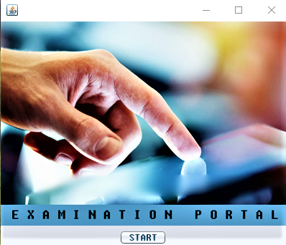
2. *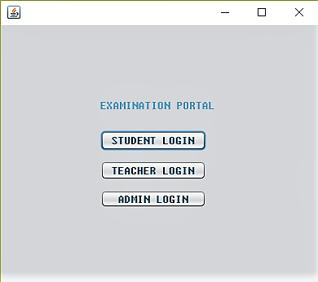Student Login*

**a.**

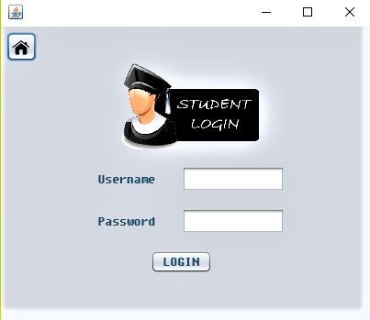**b.**

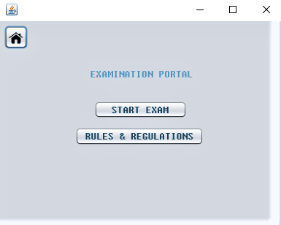

**c.**

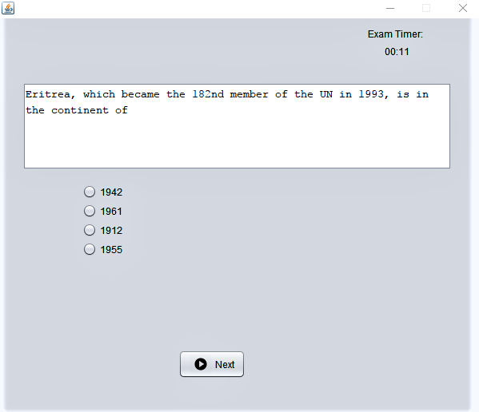

**(d)**

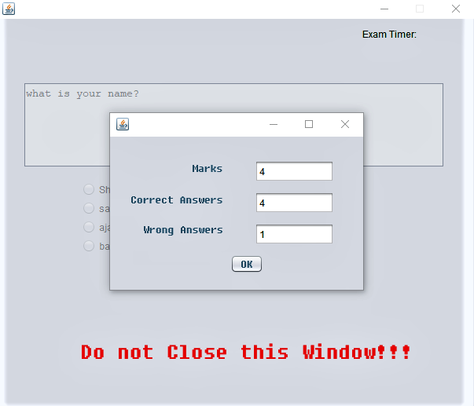

**(e)**

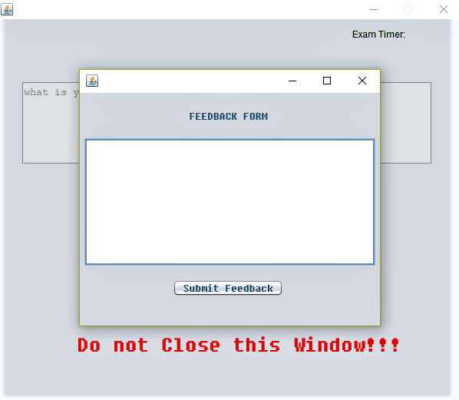

**(f)**

**3. *Teacher login***

**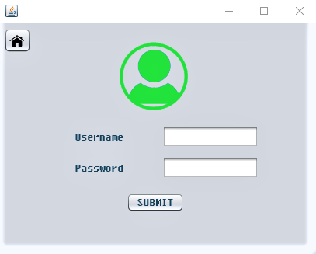 *a.***

***b..*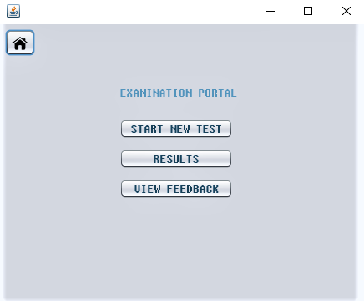**

**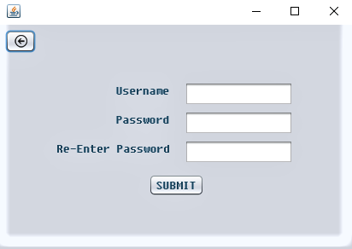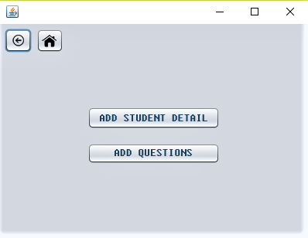*c.***

***d.***

**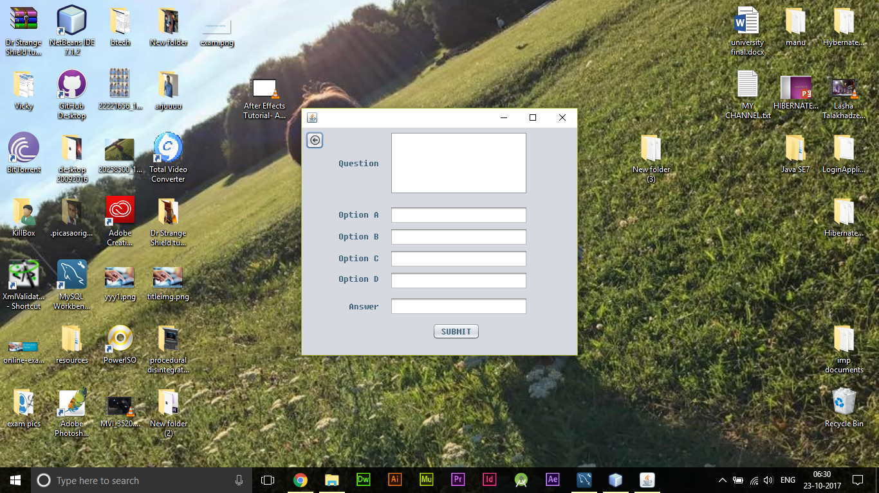*e.***

**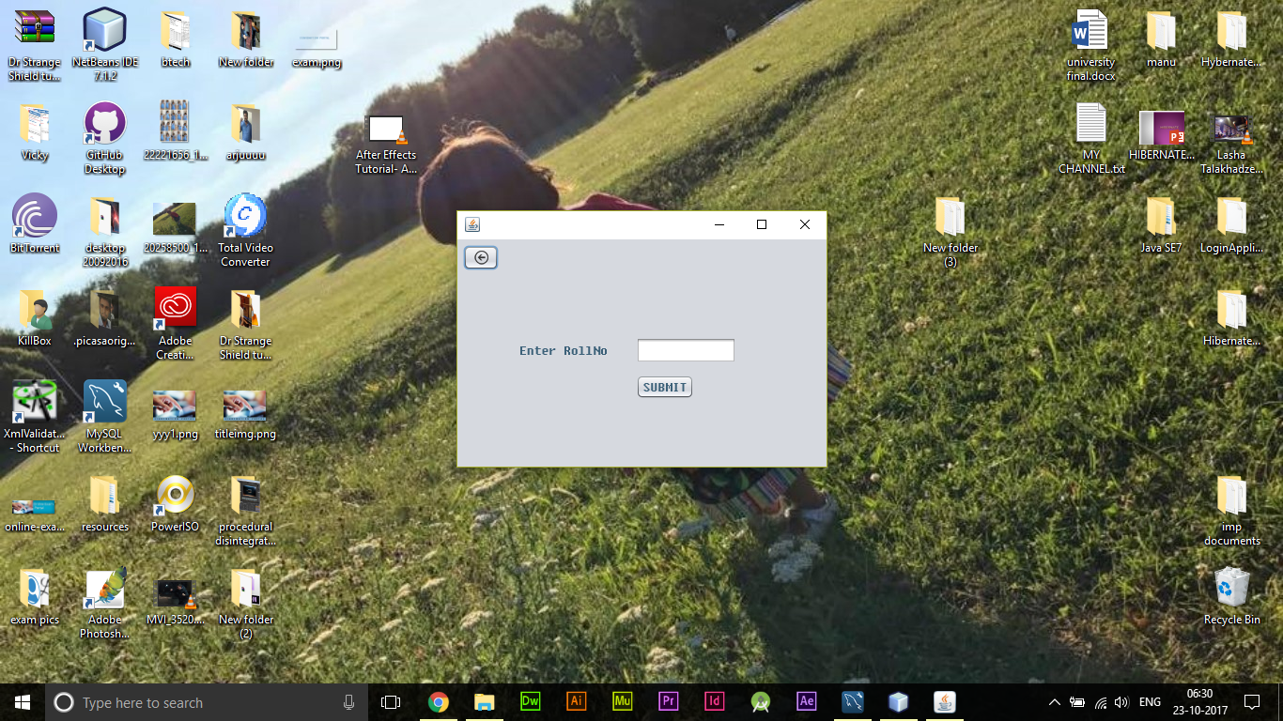*f.***

**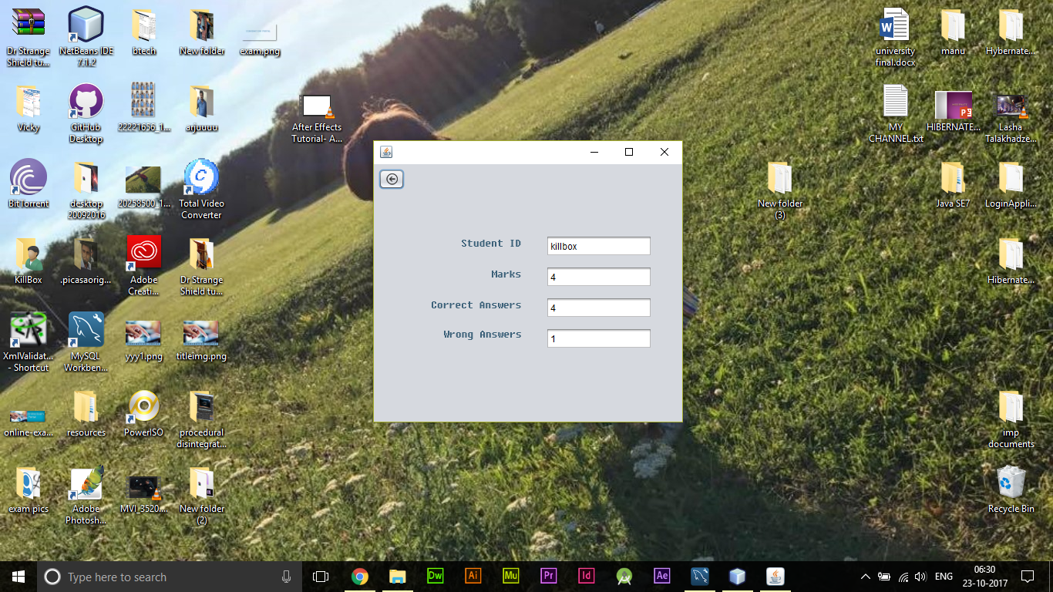*g.***

**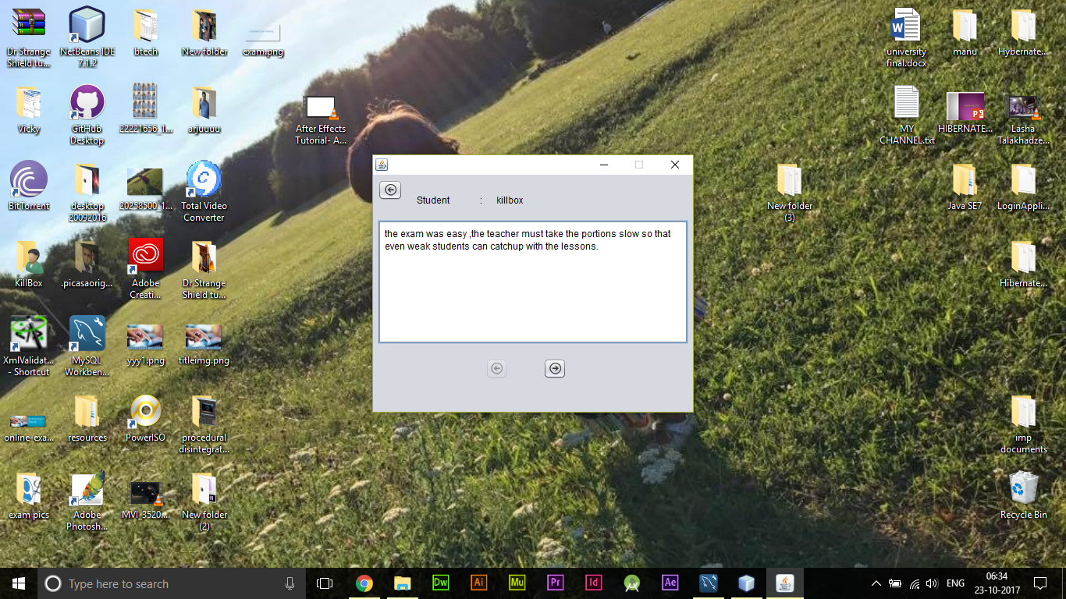*h.***

***4. Admin Login***

**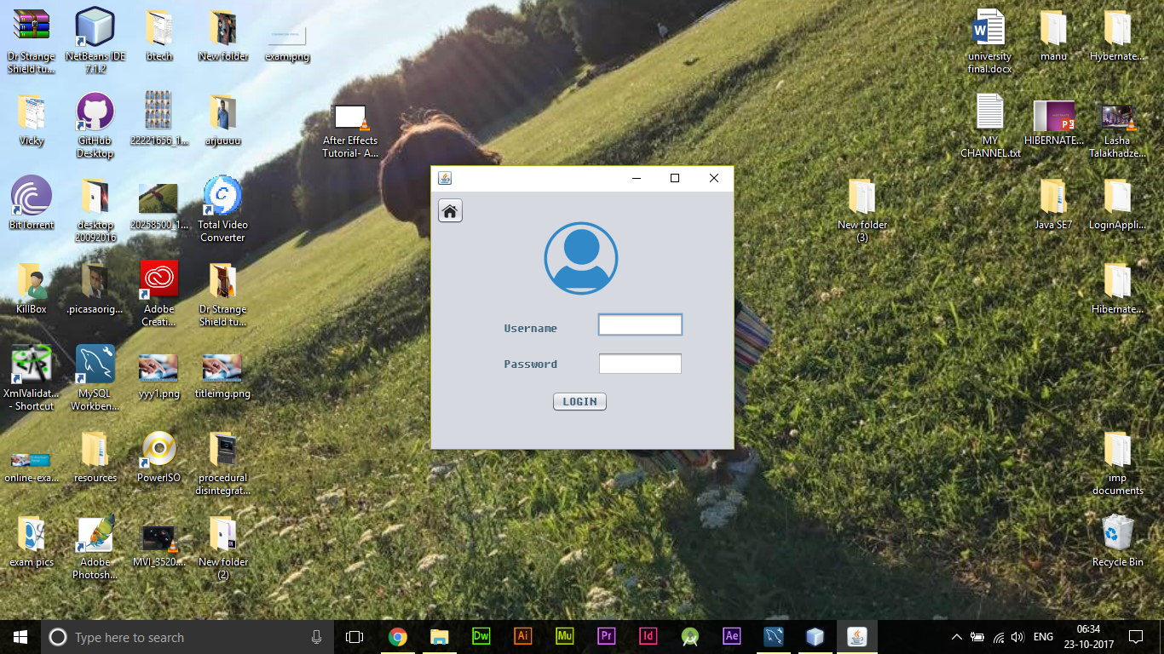 *a.***

**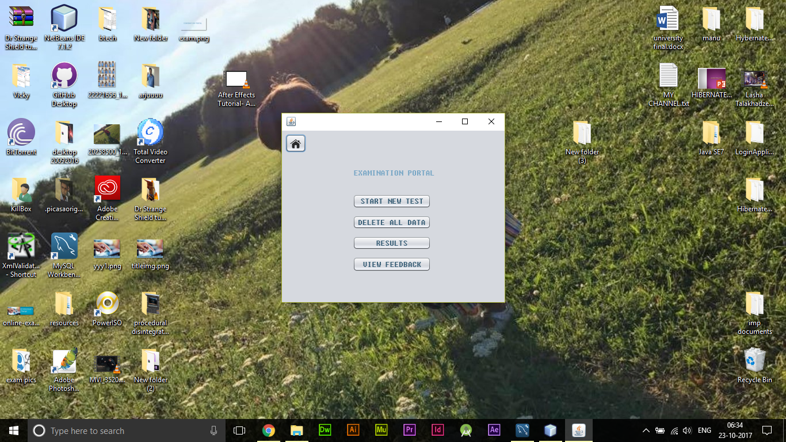 *b.***

**ADVANTAGES AND LIMITATIONS**

* Security of data.
* Ensure data accuracy’s.
* Administrator controls the entire system.
* Reduce the damages of the machines.
* Minimize manual data entry.
* Greater efficiency.
* User friendly and interactive.
* Minimum time required.

**CONCLUSION**

To overcome all the limitations we are developing a desktop application for Examination. This application will perform various tasks for students and teachers. For a student they can attend the test and this project helps a student to improve skills and time saving factor. There is no chance of human error, as the various reports will be calculated without any human intervention. The project named Offline Examination Portal is application created in NetBeans IDE 8.0.2.